

SCAF Board of Directors, Meeting Minutes
Tuesday, 05/06/2025 at 6:30pm, Zoom

Meeting started: 6:30PM

Attendance: Andrew Gates, Fred Sicard, Mike Stewart, Steve Yancey, Victoria Mezack, Mark Despars, Jae Lee, Bill Bringas, Tony Bennett, Scott Wong, Scott Voltz, Maddie Alexander

Agenda:
- Welcome and approval of minutes (Gates)
- College List requirements (Fred and AEG)
- Endorsement from current or previous Fina ref
- Endorsement from college assigner
- Minimum of three years of High School Reffing
- Prior college reffing experience
- JO finals, CIF Semi or Final (Better consideration for high level divisions)
- Demonstrate desire to grow and move up
- Clinic Dates
- Clinic 1 - Aug. 3 (Rules test to go out Aug. 2)
- Clinic 2 - Aug. 10 (Test due Aug. 9)
- Clinic 3 - Sept. 28
- Clinic 4 - Nov. 16
- Clinic 5 - Jan. 11, 2026
- Registration (Tiffany and Mark)
- To be discussed and letter sent out by June 1st
- Late fee July 1st
- New Business
- Sponsorship for gear proposed by Wong: Bylaw amendments per area. We are nonprofit:spend what’s given. Product is ok.
- Logos on gear (Gates to reach out to CIF to see what guidelines are)

Next scheduled meeting August 13th, 2025, 7:00PM.
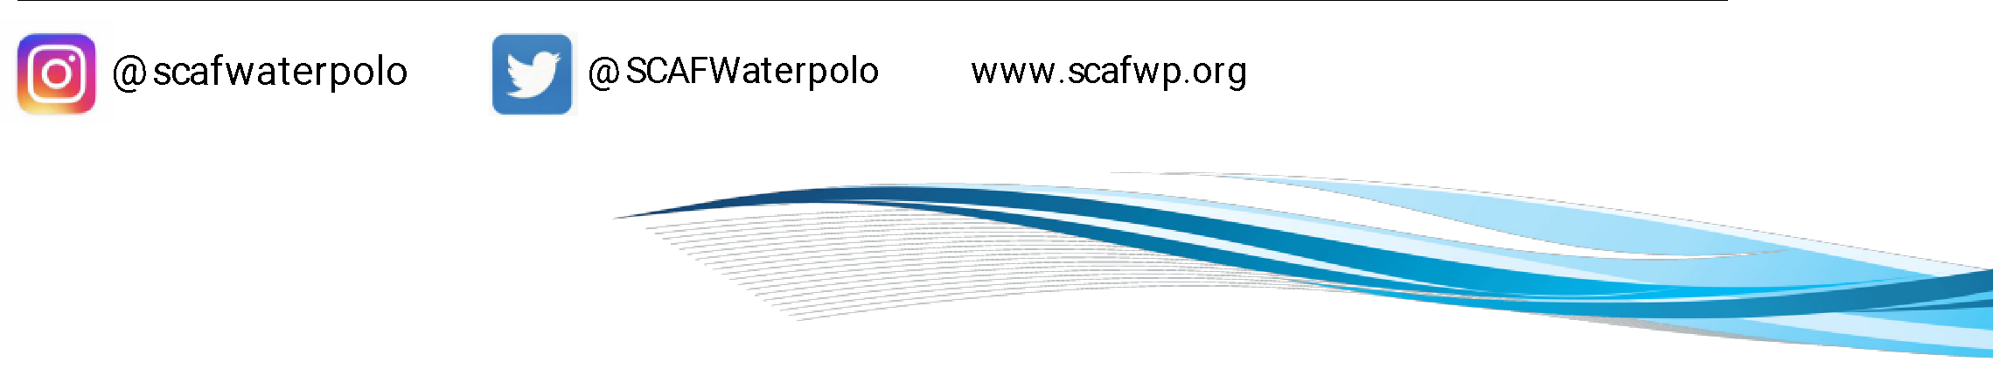
Meeting adjourned: 7:08PM

